# NITTE MEENAKSHI INSTITUTE OF TECHNOLOGY

(AN AUTONOMOUS INSTITUTION, AFFILIATED TO VISVESVARAYA TECHNOLOGICAL UNIVERSITY, BELGAUM, APPROVED BY AICTE & GOVT.OF KARNATAKA



# 

# PROJECT REPORT

# on

E-COMMERCE LEARNING

*Submitted in partial fulfilment of the requirement for the award of Degree of*

*Bachelor of Engineering*

*In*

*Information Science and Engineering*

*Submitted by:*

**K GOVIND RAJ 1NT20IS069**

**PALO HARIPRIYA 1NT20IS105**

Under the Guidance of

Prashanth B S& Evangeline Ma’am

Assistant Professors, Dept. of ISE, NMIT



Department of Information Science and Engineering

**(Accredited by NBA Tier-1)**

2022-2023

(AN AUTONOMOUS INSTITUTION, AFFILIATED TO VISVESVARAYA TECHNOLOGICAL UNIVERSITY, BELGAUM

## Department of Information Science and Engineering

**(Accredited by NBA Tier-1)**



**CERTIFICATE**

This is to certify that the Project Report on “**E-COMMERCE LEARNING WEBSITE”** is an authentic work carried out by **K GOVIN RAJ (1NT20IS069) and PALO HARIPRIYA (1NT20IS105).** Bonafede students of Nitte Meenakshi Institute of Technology, Bangalore in partial fulfilment for the award of the degree of Bachelor of Engineering in Information Science and Engineering of Visvesvaraya Technological University, Belagavi during the academic year 2022-2023***.*** It is certified that all corrections and suggestions indicated during the internal assessment has been incorporated in the report.

Mr.Prashanth BS & Ms.Evangeline Assistant Professor, Dept. ISE,

NMIT Bangalore

# Abstract

This document describes the design and development of an e-commerce learning website on data science using HTML, CSS, JS, Node.js, MongoDB, and Express. The website aims to provide online courses and resources for learners who want to acquire data and AI skills at their own pace. The website is dynamic in nature that is the administrator can make the changes directly without being worried about the backend.

The website's interface provides an intuitive and user-friendly experience, making it easy for users to search for specific courses based on specific domain. One of the key features of the website is the ability for users to be able to ask their queries. Overall, this website serves as a comprehensive platform that brings together individuals who are passionate towards learning. It promotes creativity, encourages culinary exploration, and provides a supportive environment for learners to connect and share their knowledge with the community

# Acknowledgement

The satisfaction and euphoria that accompany the successful completion of any task would be incomplete without the mention of the people who made it possible, whose constant guidance and encouragement crowned our effort with success. I express my sincere gratitude to our Principal **Dr. H. C. Nagaraj**, Nitte Meenakshi Institute of Technology for providing facilities.

We wish to thank our Hood**, Dr. Mohan S. G.** for the excellent environment created to further educational growth in our college. We also thank him for the invaluable guidance provided which has helped in the creation of a better project.

I hereby like to thank our ***Mr.Prashanth B S & Ms. Evangeline, Assistant Professors*** Department of Information Science & Engineering on their periodic inspection, time to time evaluation of the project and help to bring the project to the present form.

Thanks to our Departmental Project coordinators. We also thank all our friends, teaching and non-teaching staff at NMIT, Bangalore, for all the direct and indirect help provided in the completion of the project.

Table of Contents

**Abstract Acknowledgment**

|  |  |  |
| --- | --- | --- |
| **Sl.no** | **Chapter Title** | **Page**  **Number** |
| 1 | Introduction | 1 |
| 2 | Literature Review | 2-4 |
| 3 | Problem statement | 5 |
| 4 | Technology Specifications | 6 |
| 5 | Implementation | 7-11 |
| 6 | Results and Snapshots | 12-14 |
| 7 | Conclusion | 15 |

**References**



**Chapter-1**

# INTRODUCTION

### Data science and AI are among the most sought-after skills in the current market. However, finding quality and affordable learning materials can be challenging for many learners. Therefore, this project aims to create an e-commerce learning website that offers various data science and AI courses and resources for different levels of learners. The website also leverages data science and machine learning techniques to enhance the customer experience and increase sales.

### Node.js

Node.js is an open source, cross-platform runtime environment for developing server-side and networking applications. Node.js applications are written in JavaScript, and can be run within the Node.js runtime on OS X, Microsoft Windows, and Linux. Node.js uses an event-driven, non-blocking I/O model that makes it lightweight and efficient, perfect for data-intensive real-time applications that run across distributed devices.Node.js also provides a rich library of various JavaScript modules which simplifies the development of web applications using Node.js to a great extent.

### Using MongoDB Database

The open-source MongoDB document and NoSQL database was created in C++. The data is stored in a comparable way using JSON-like documents in MongoDB, and NoSQL is used to access the data. A document database called MongoDB was created to make it simple to

Develop applications. A document, or record, in MongoDB is a data structure made up of field and value pairs.

**Summary**:

This chapter gives brief introduction to the project and technological architecture of Django is discussed.

**Chapter-2**

# LITERATURE REVIEW AND OBJECTIVES

### Node.js

Node.js is an open source, cross-platform runtime environment for developing server-side and networking applications. Node.js applications are written in JavaScript, and can be run within the Node.js runtime on OS X, Microsoft Windows, and Linux. Node.js uses an event-driven, non-blocking I/O model that makes it lightweight and efficient, perfect for data-intensive real-time applications that run across distributed devices.

### Mongodb

MongoDB is an open-source document and NoSQL database written in C++. MongoDB uses JSON-like documents to store data in a similar format. A document database designed to facilitate application development. A record in MongoDB is a document, a data structure made up of field-value pairs. A MongoDB document resembles a JSON object. Field values can contain other documents, arrays, and arrays of documents.

### HTML

HTML (Hypertext Markup Language) is the standard markup language for creating web pages and applications. It uses tags to structure the content and define its presentation. HTML allows for the inclusion of various elements such as headings, paragraphs, images, links, and forms. It forms the backbone of web development, enabling the creation of interactive and visually appealing websites that can be viewed on different devices and browsers.

### CSS

CSS (Cascading Style Sheets) is a style sheet language used to describe the presentation and visual appearance of HTML documents. It provides a set of rules and properties to control the layout, colors, fonts, and other aspects of web pages. CSS allows developers to separate the structure and content of a website from its design, making it easier to maintain and update the visual aspects across multiple pages or an entire website.

### JavaScript

JavaScript is a versatile programming language used for web development and beyond. It enables dynamic and interactive elements on web pages, such as form validation, content updates, and user interface enhancements. With its wide range of libraries and frameworks, JavaScript can also be used for server-side development, mobile app development, and even desktop applications. Its flexibility and ubiquity make it a fundamental tool for modern web development.

### Mongodb connection with Node js

The steps to connect mongodb with Node.js.

* + - Install the MongoDB Node.js driver.
    - Require the MongoDB module in your Node.js application.
    - Set up the connection URL and options.
    - Connect to MongoDB using the Mongo Client
    - Perform database operations within the connection callback. For example, you can perform CRUD operations on a collection.

To connect MongoDB with Node.js, install the MongoDB Node.js driver. Require the MongoDB module in your code. Set up the connection URL and options. Use the `MongoClient` to connect to MongoDB, providing the URL and options. Perform database operations within the connection callback, such as inserting documents or querying collections. Close the connection when finished. Additional libraries like Mongoose and TypeORM provide more features and abstraction for MongoDB interactions in Node.js.

### Objectives

* website strives to deliver the optimal courses and services that cater to the users’ learning needs The and goals.
* The website fosters a community of inquisitive learners who can engage, interact, and collaborate with each other.
* The website provides a user-friendly interface that facilitates users to browse for courses, navigate the site, and contribute to the community.
* The website supports users to seek help if they encounter any challenges or doubts regarding the projects.
* To implement a dynamic pricing system that adapts the prices of the courses and resources according to the market demand and supply.

Top of Form

Bottom of Form

**Summary:** This chapter gives information about the literature survey and objectives of the literature review and about the interfacing of mongodb with Node.js

**Chapter-3**

# PROBLEM STATEMENT

The main problem that this project addresses is how to create an attractive, user-friendly, and functional e-commerce learning website on data science using modern web technologies. The website should provide online courses and resources for learners who want to acquire data and AI skills at their own pace. The website should also leverage data science and machine learning techniques to enhance the customer experience and increase sales.

**Summary**: This chapter tells about the Problem statement.

**Chapter-4**

# TECHNOLOGY SPECIFICATION

### Overview

An e-commerce learning website typically consists of the following features:

* A catalog of courses and resources that cover topics such as e-commerce fundamentals, marketing, sales, customer service, web development, analytics, and more.
* A user interface that allows learners to browse, search, filter, and enroll in the courses and resources of their choice.
* A learning management system that allows learners to access the courses and resources, track their progress, take quizzes and tests, earn certificates, and interact with instructors and peers.
* A feedback system that allows learners to rate and review the courses and resources, provide suggestions for improvement, and report any issues or problems.

### Software Requirements

* + - Mongodb with NodeJS
    - HTML, CSS, JAVASCRIPT
    - Visual Code Studio
    - Web Browser: Microsoft Internet Explorer, Mozilla, Google Chrome or later
    - Mongodb (back-end)
* Operating System: Windows 7/ Windows 10/MAC

**Summary**: This chapter gives information about the technologies used for implementing this project.

**Chapter-5**

# IMPLEMENTATION

**Important code snippets**

**API’s connection**.

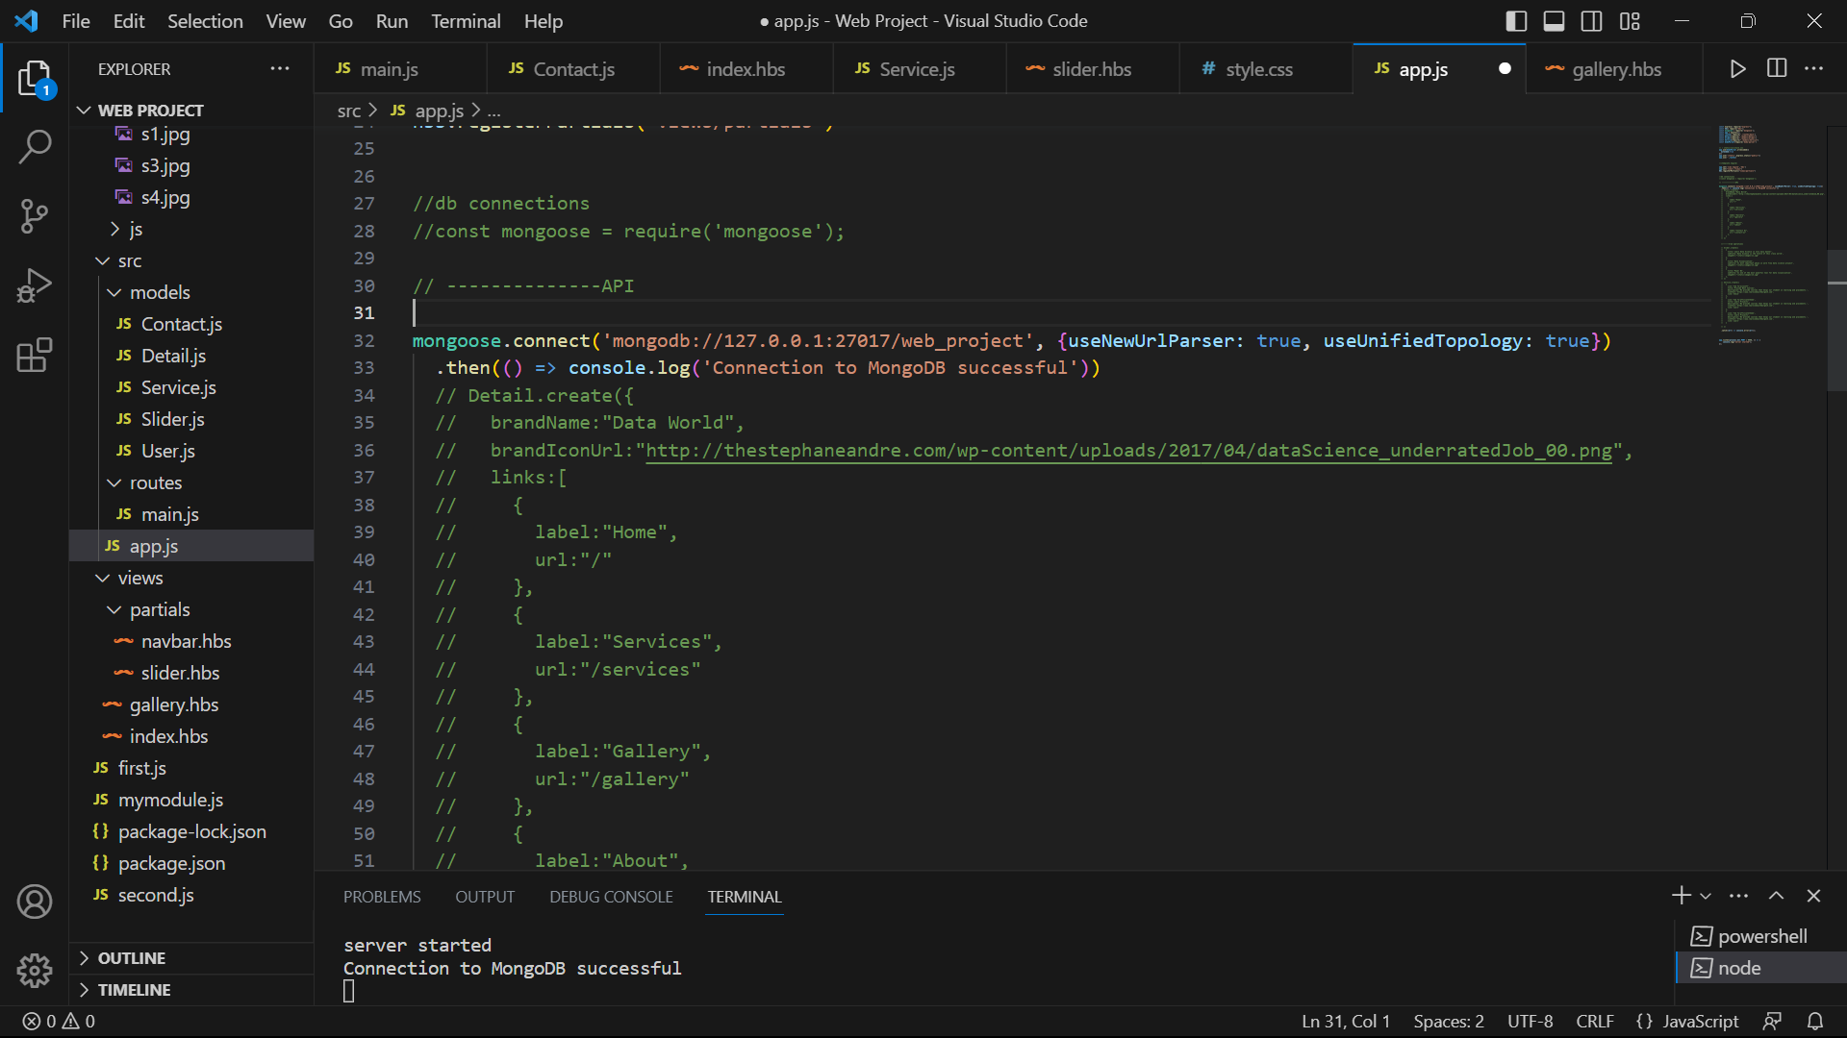

**CRUD operation:**

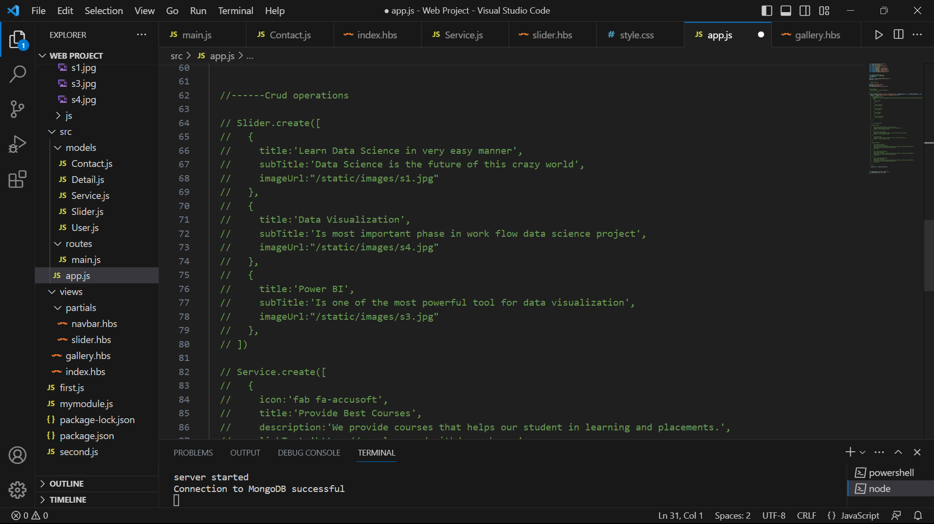

**Mondodb Connection**

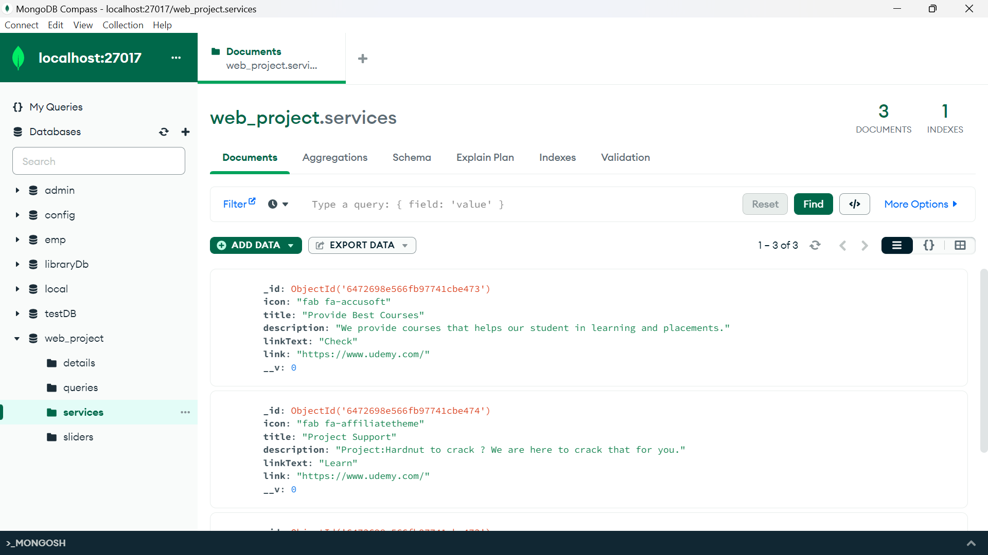

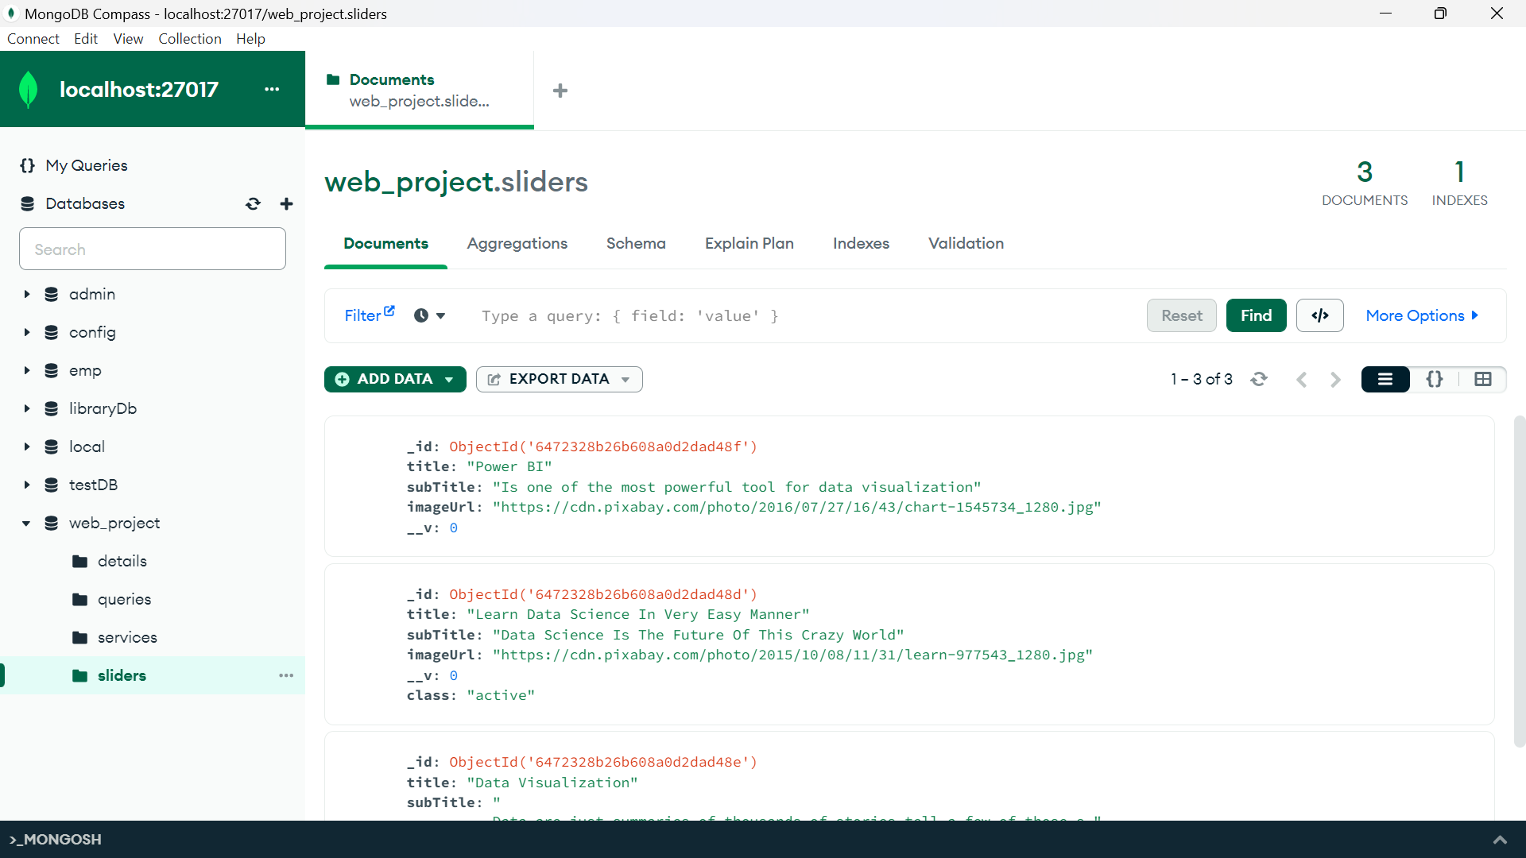

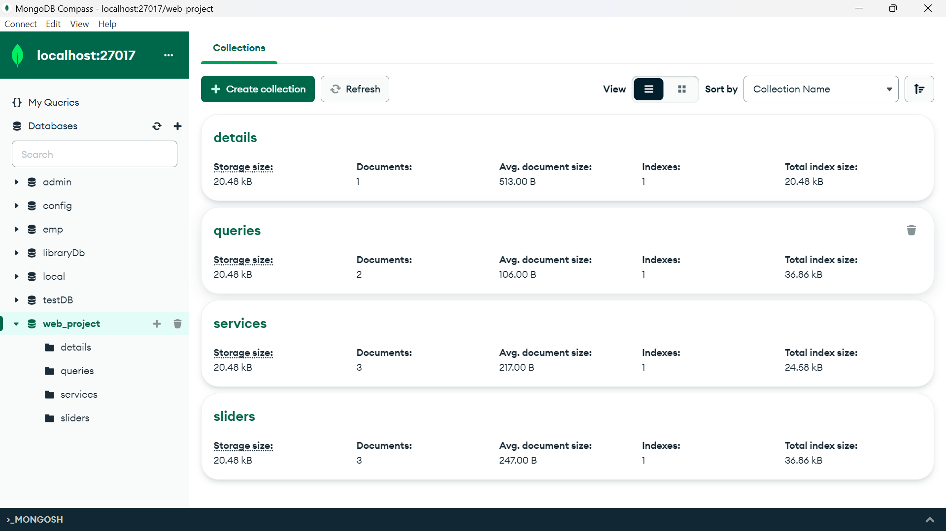

**Summary:** This chapter gives a look into the used important code snippets for this project.

**Chapter-6**

# Results and Snapshots

Snapshot 1,2: The following figure shows the home page

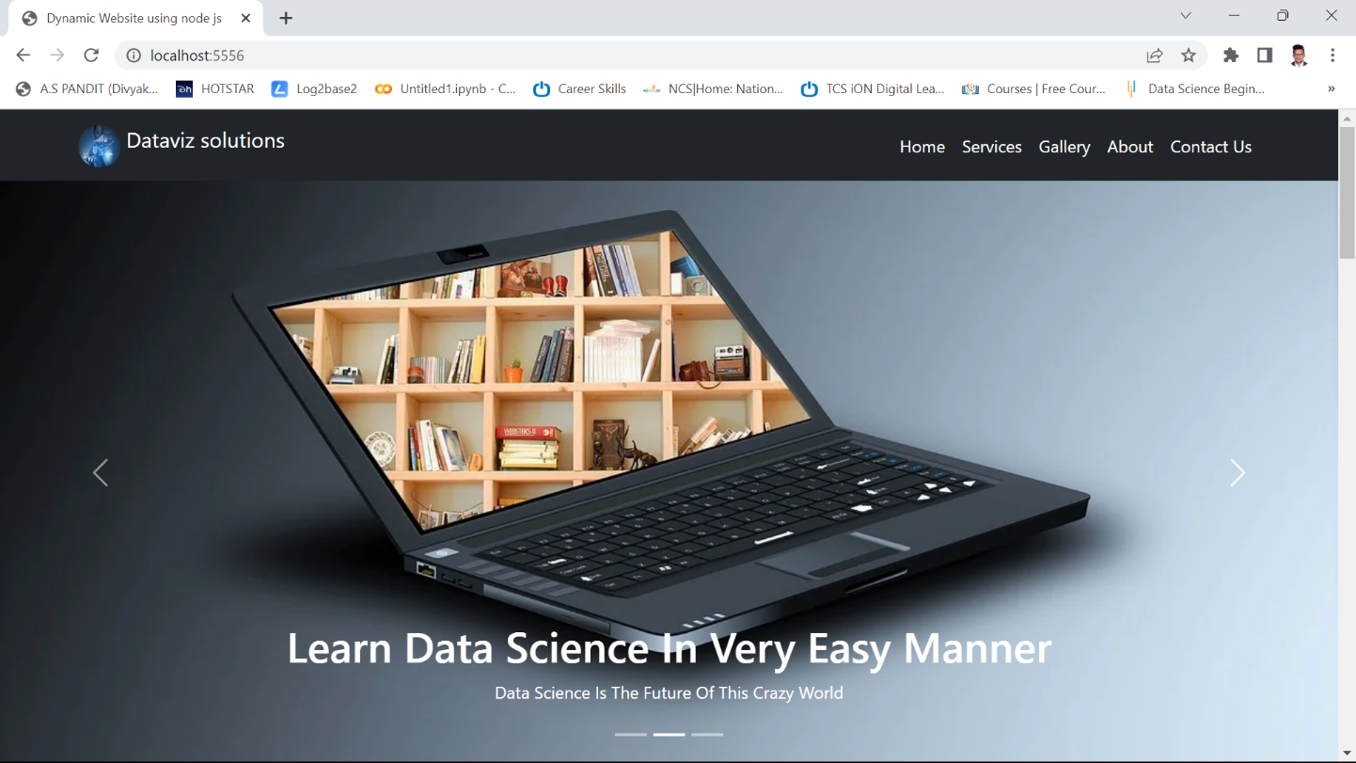

***Figure . Home page***

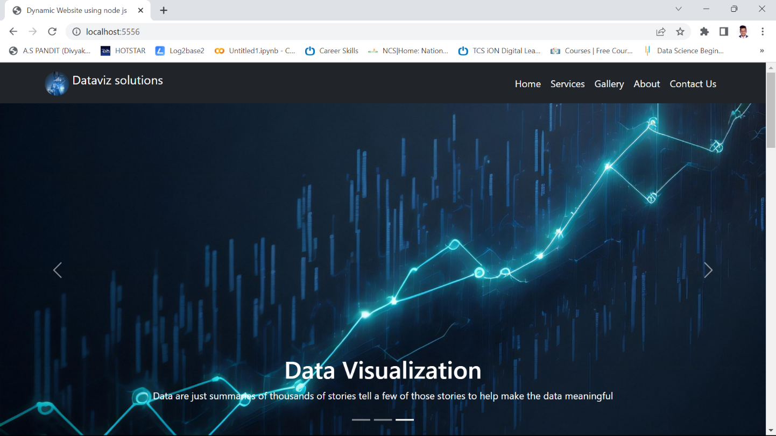

***Figure . Home page***

Snapshot 3: About Page

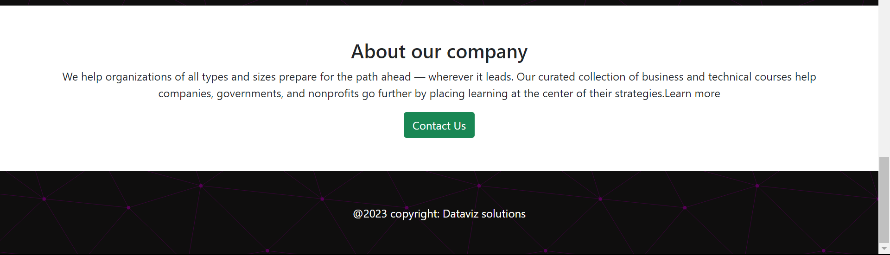

***Figure . About page***

Snapshot 4: Our Services

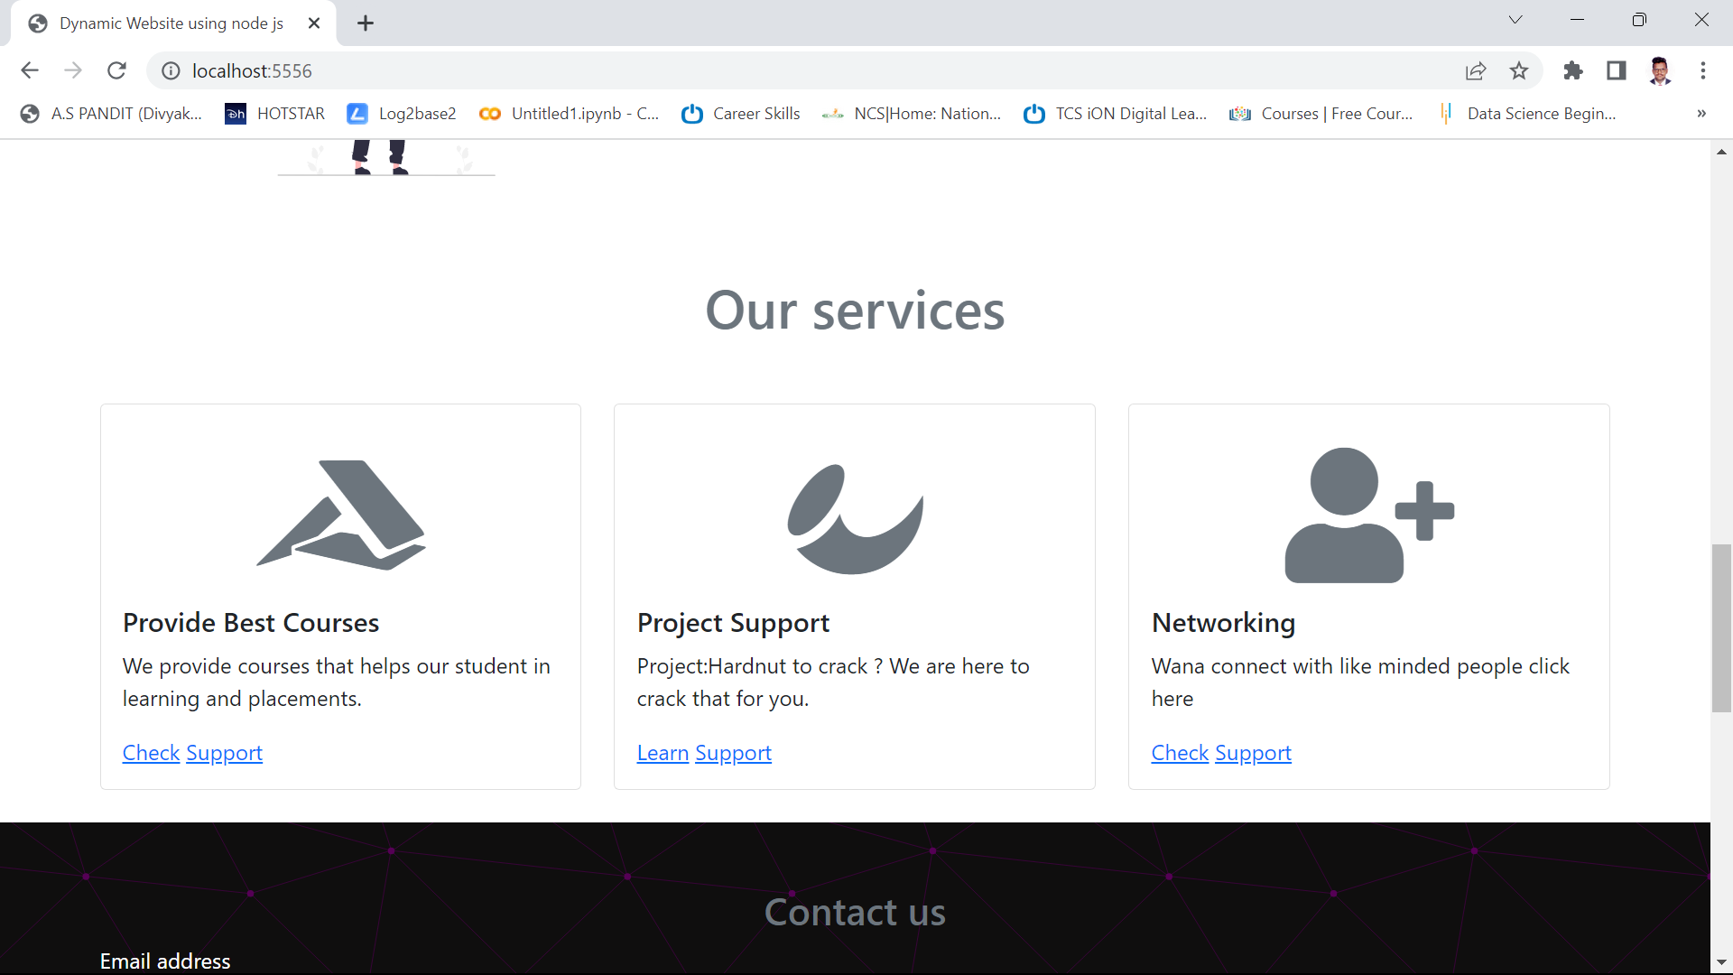

***Figure ,our services page***

Snapshot 5: contact Us page

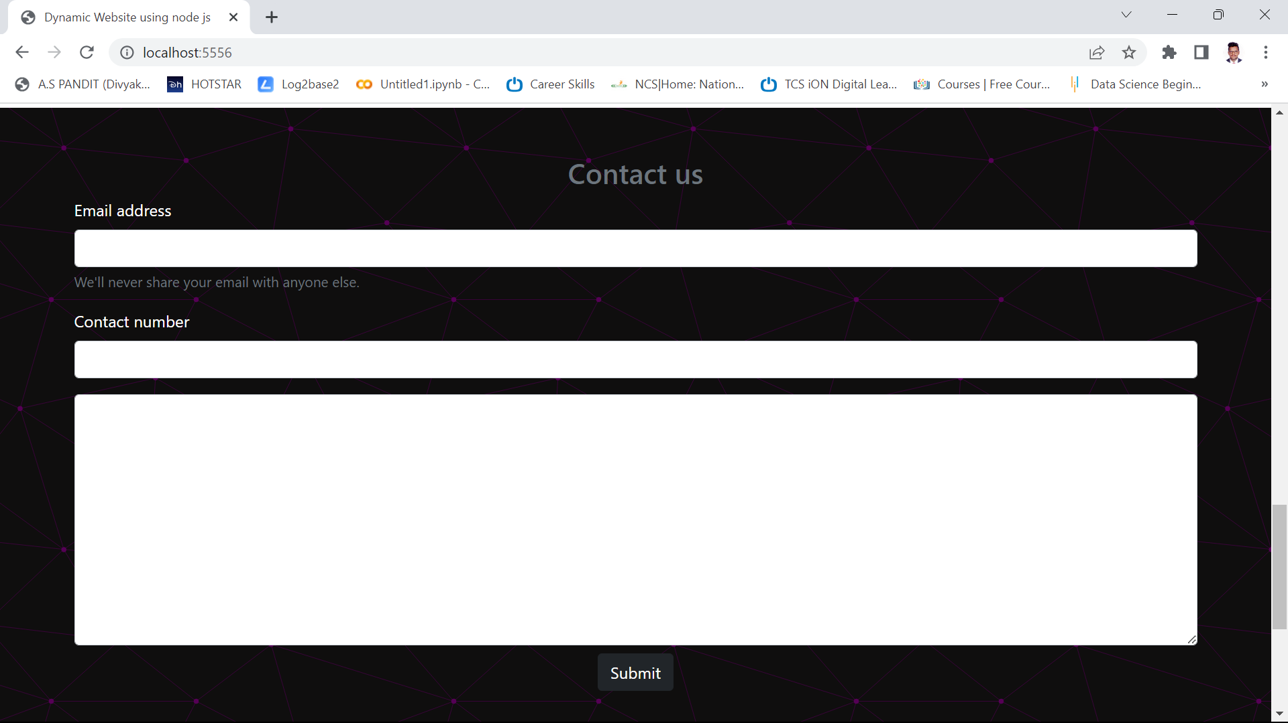

***Figure . contact us***

Snapshot 6: Start Learning Page

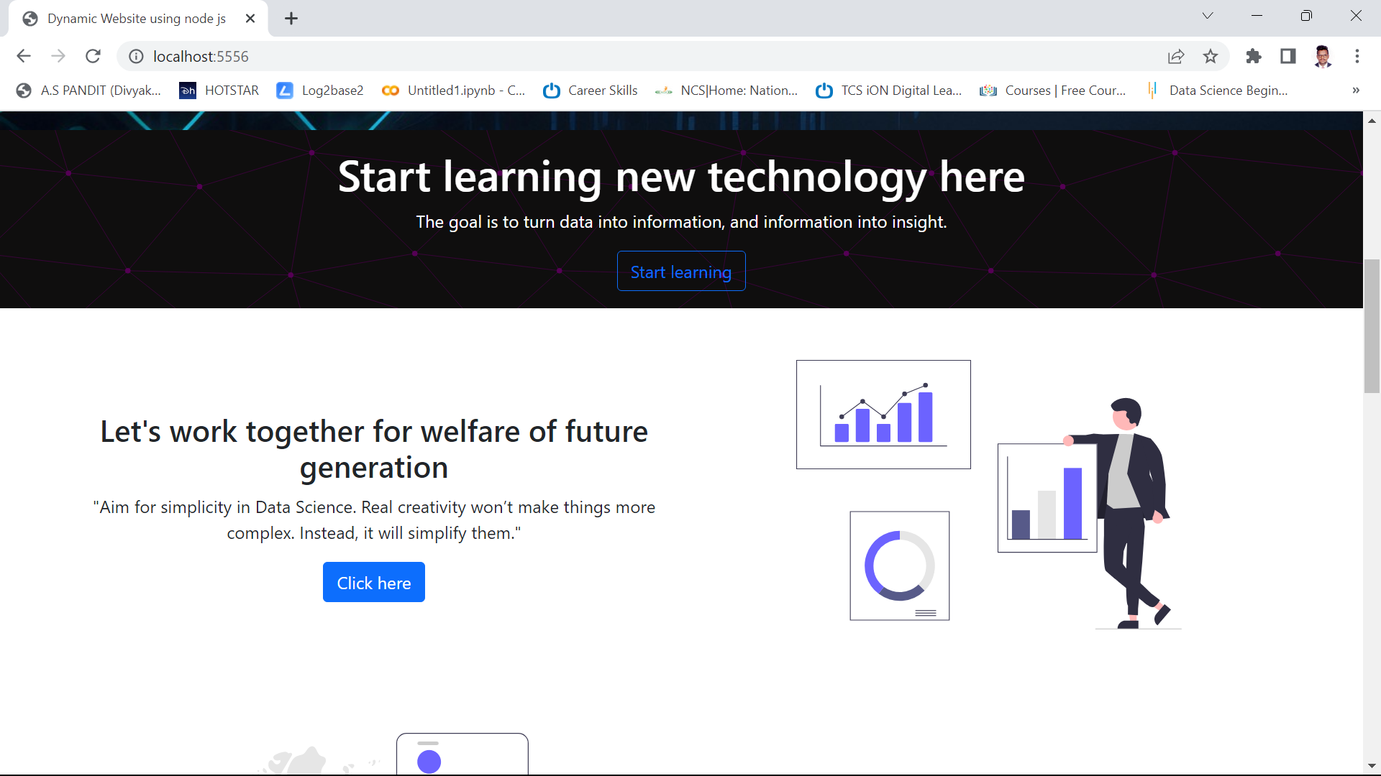

***Figure. Recipe display page***

**Chapter-7**

**CONCLUSION**

This project aims to create an e-commerce learning website on data science using HTML, CSS, JS, Node.js, MongoDB, and Express. The website will offer various data science and AI courses and resources for different levels of learners. The website will also feature a recommendation system, a dynamic pricing system, and a customer behavior forecasting system based on machine learning algorithms. The website will provide a high-quality and personalized learning experience for the customers and increase their satisfaction and loyalty. The website will also generate more revenue and profit for the business by optimizing the prices and predicting the customer behavior.

# REFERENCES

# <https://www.mongodb.com/atlas/database>

# <https://www.mongodb.com/>

# <https://rapidapi.com/hub>

# <https://www.postman.com/>